**Assignment 7.3**

**Write a custom key to evaluate the number of people who died and the number of people who survived, along with their genders.**

**Input file:**

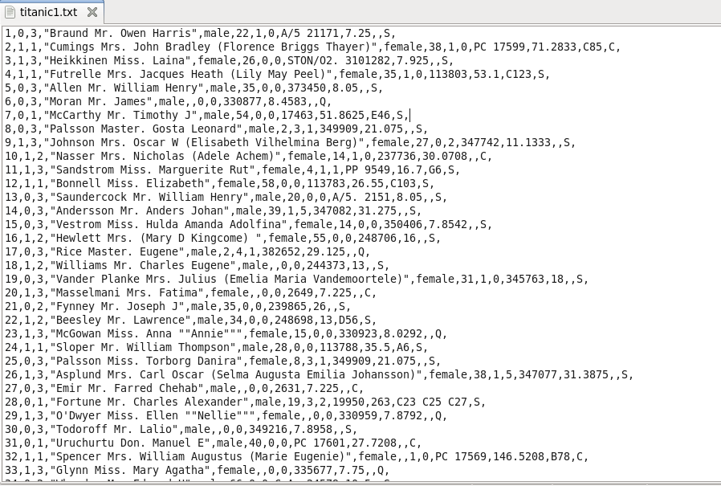

**Driver Class:**

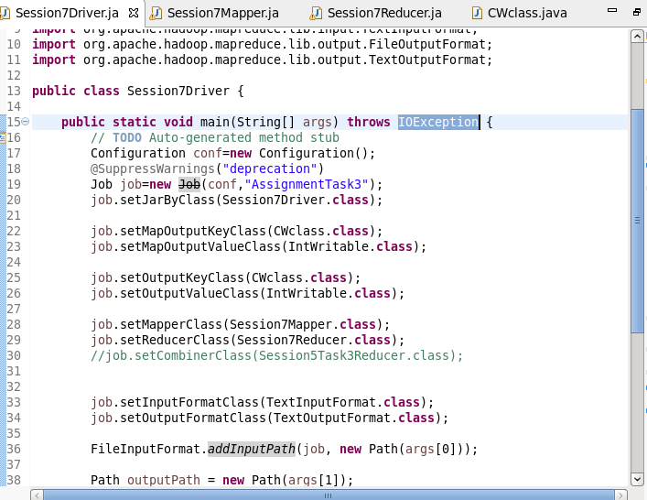

**Mapper class:**

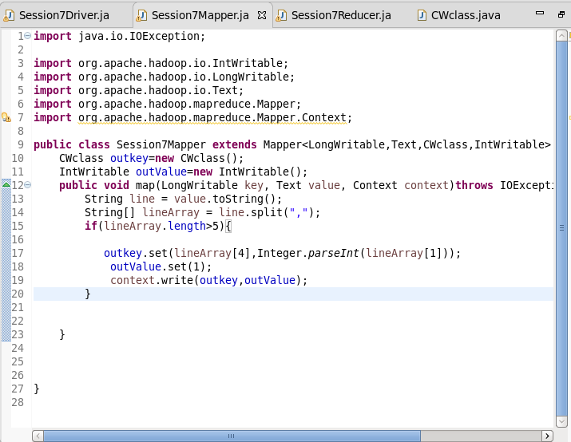

**Reducer Class:**

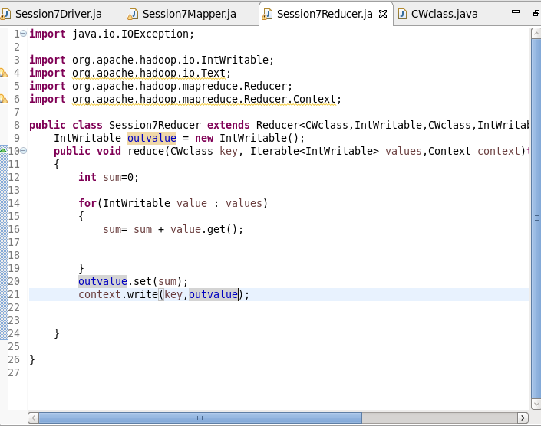

**Comparable writable:**

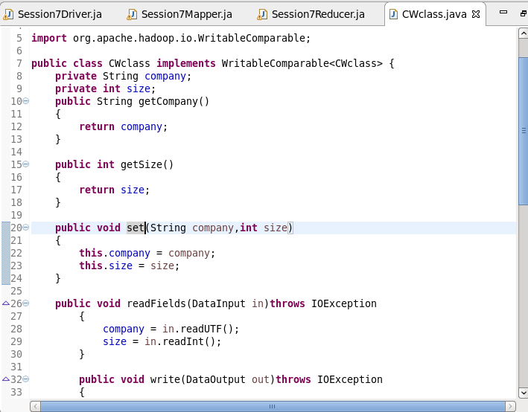

**Output:**

